About Application:

It’s a one page application, in modern terms people want all actions in same page with minimal number of inputs.

Any action in the app will take you to the AI chatbot which will raise request, solve queries etc.

Connect with trusted beneficiaries like social media page and make transaction

ML scripts which can provide customer with financial information, products that can save them and customize products for their need. Not yet implemented.

How to RUN the Backend Spring Boot Application

1. In Spring Tool Suite/IntelliJ import the project as existing maven project “select backend folder”
2. Build project using maven, in Spring Tool Suite IDE we used maven plugin

Under Run Configuration:

Base Directory: ${project_loc:backend}

Goal: clean package

1. Run the application, in Spring Tool Suite run => Spring Boot App

As the Backend application is created using Spring Boot inbuilt TOM cat server, the Spring boot application will be up and running after 3rd street.

The following are the endpoints:

<http://localhost:8080/transactionlist>

<http://localhost:8080/loansummary>

<http://localhost:8080/creditcardummary>

<http://localhost:8080/accountsummary>

<http://localhost:8080/health>

How to RUN the Frontend REACT Js Application:

1. In Visual Studio Code open folder “select frontend folder”
2. Remove the package-lock.json
3. Remove all the contents of frontend/node_modules folder
4. In VS terminal run command npm install --legacy-peer-deps
5. After all modules are installed, In the VS terminal run command npm run.

The application will be up and running in the following url:

<http://localhost:3000/natwest/hyperconnect/dashboard>

Screenshots:

1)

Summary using ML scripts:

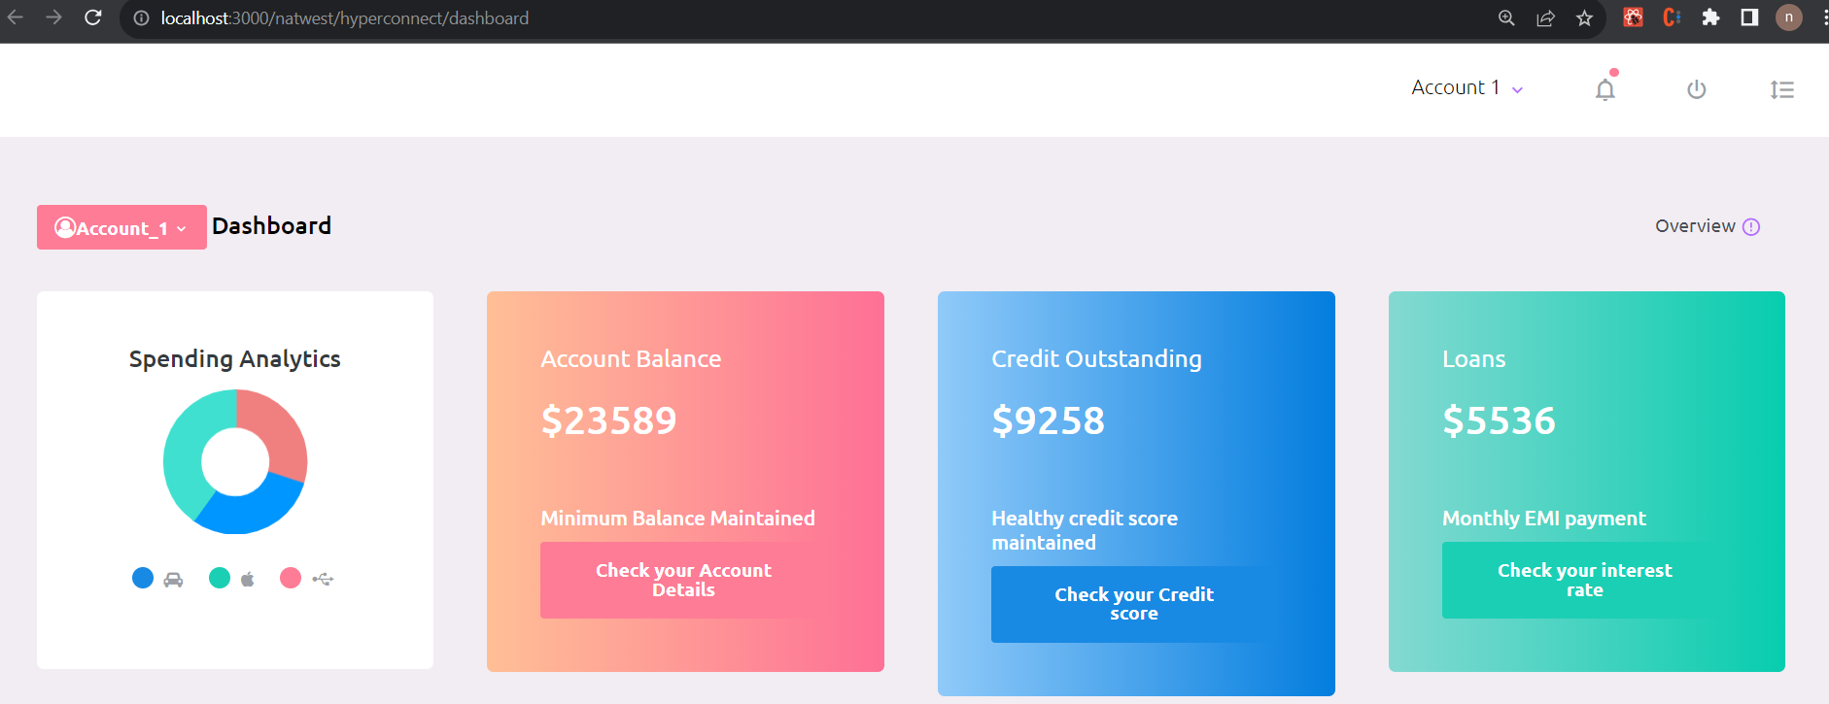

2)

ML aided tailored products for customers

All transactions and journey with the bank

Customized Ready to do Action buttons

Connect with Beneficiaries as trusted beneficiaries are your friends, family, college, regular vendors etc.

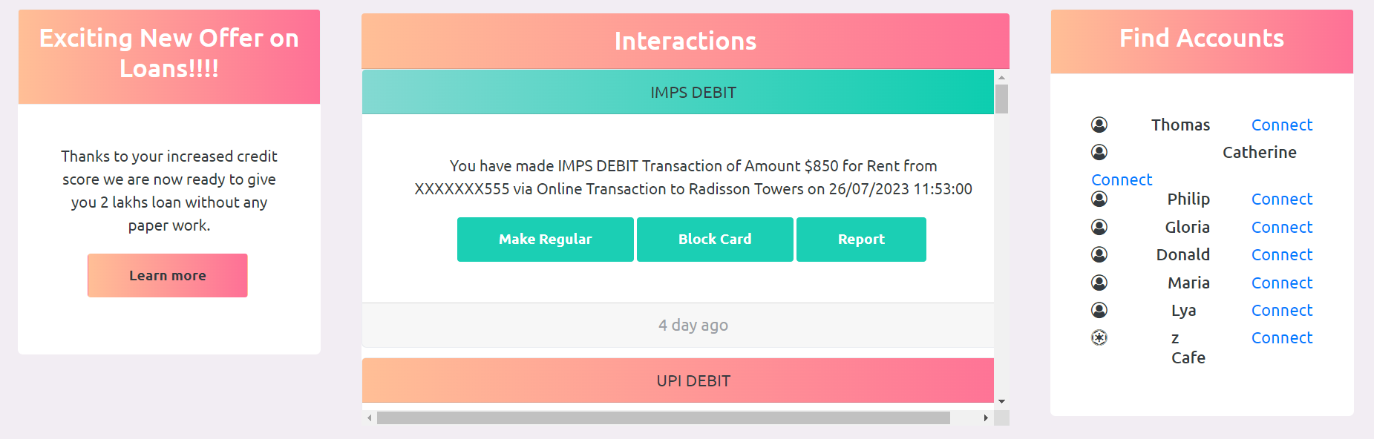

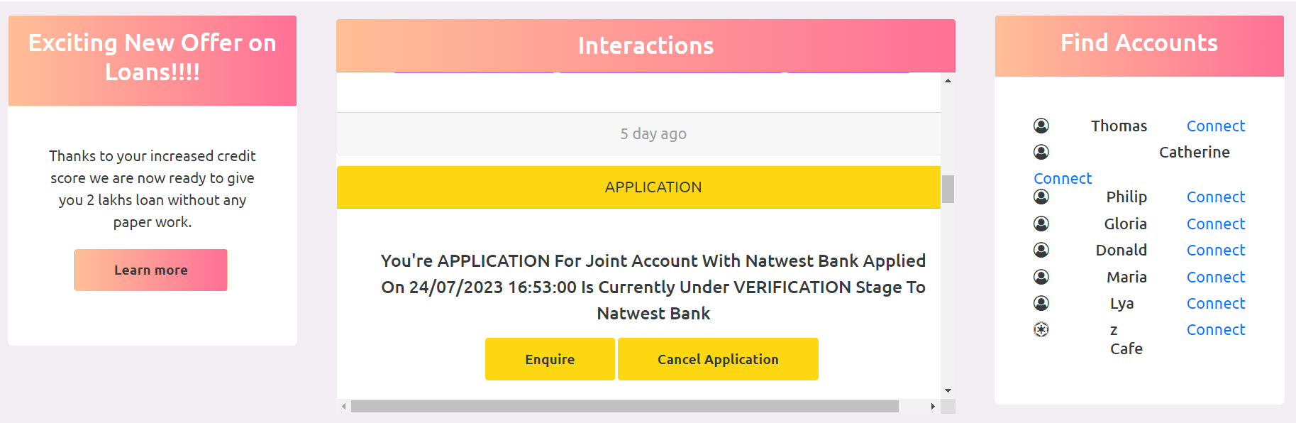

3)

All Ready to Action Buttons will open AI chat box to request, raise or solve actions.

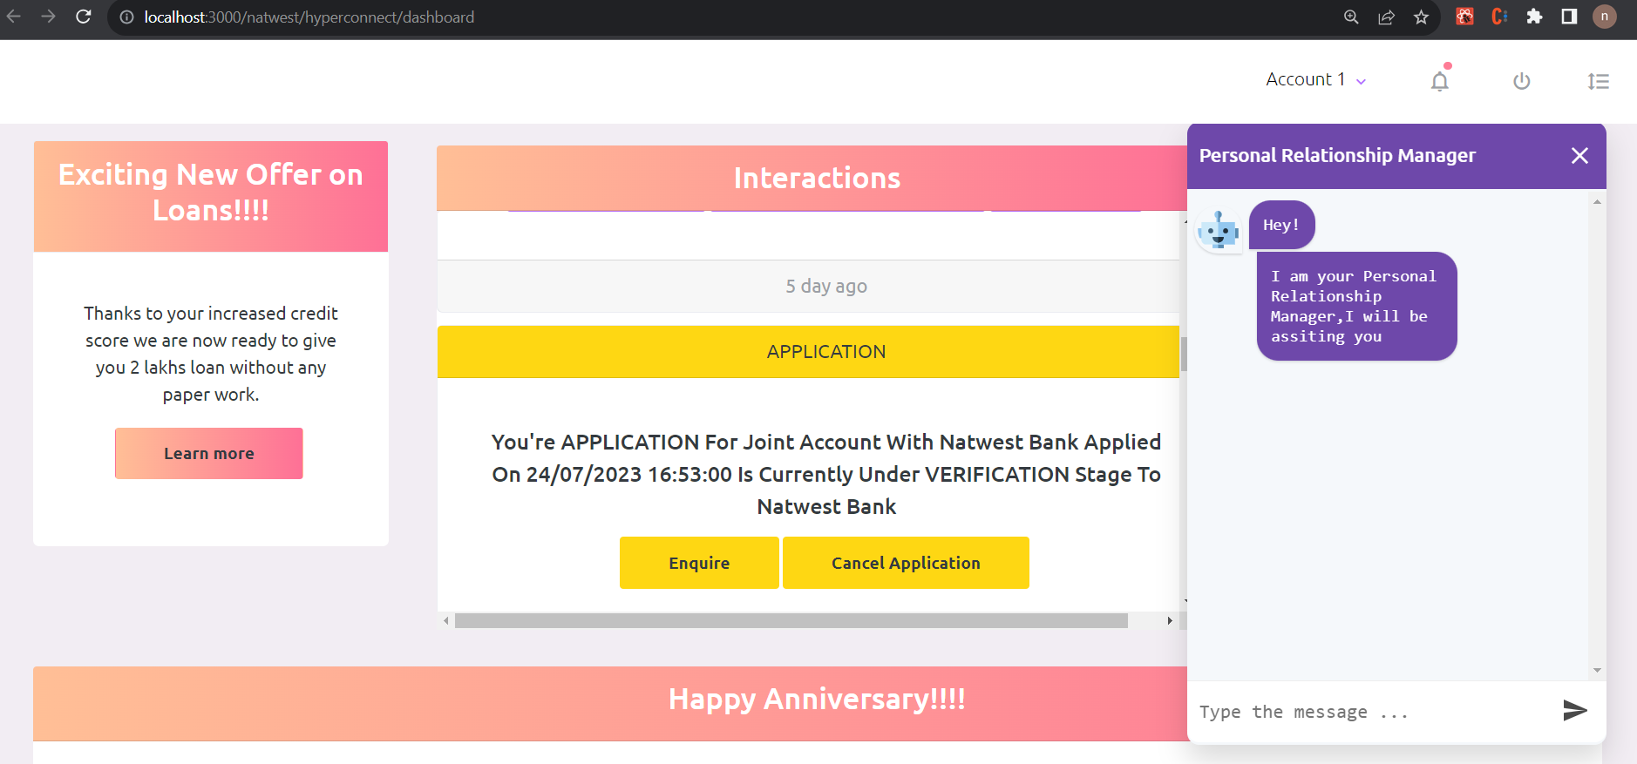

Reminders and Easy click transactions

